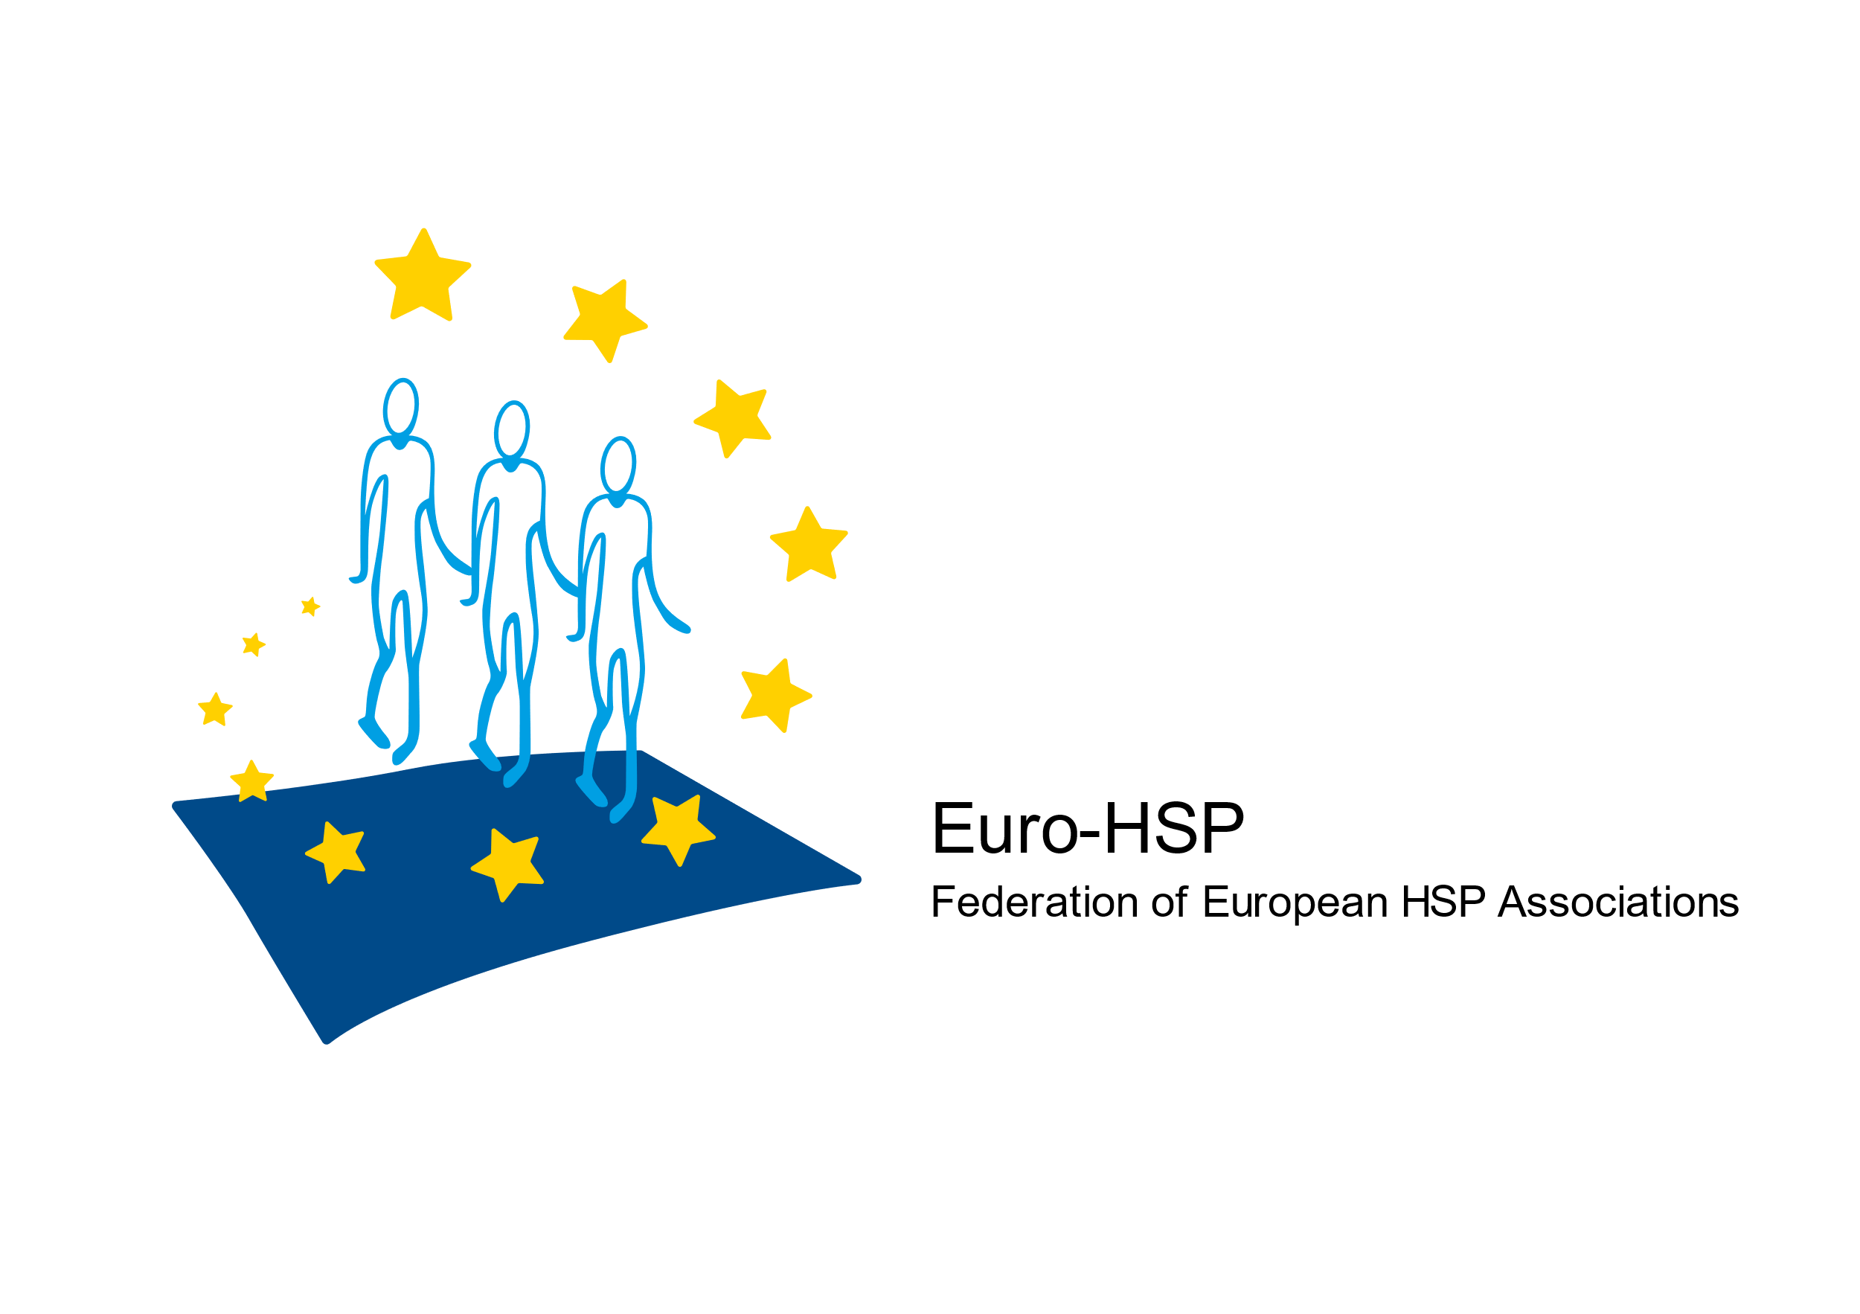 

**Best Paper Award**

**Adolf-Struempell-Prize 2025 for HSP-Therapy**

Donated by the Federation of European HSP Associations (Euro-HSP)

in Cooperation with the Tom Wahlig Foundation

**Scope:**

The Adolf-Struempell-Prize aims to honor outstanding achievements in clinical research in the field of **symptomatic and causal therapy of hereditary spastic paraplegia** and related diseases.

The awarded prize amounts to **EUR 2.500,-.**

**Criteria for Application:**

* Applicants must be the first or last author of an article in a scientific journal referenced in Medline.
* The publication date is not more than 18 months ahead of the submission deadline or the paper is “in press” as confirmed by the editor of the journal.
* The submitted paper is in the field of symptomatic and causal therapy of hereditary spastic paraplegia and related diseases and contains analysis of human data.
* At the date of the submission deadline the applicant has not exceeded 40 years of age.
* Each applicant should not submit more than one application.
* The applicant has not applied for other awards for the same paper in the same period.
* The applicant did not receive the Adolf-Struempell-Prize before.

Each applicant confirms her/his willingness to present his work during the ceremony at the Tom Wahlig Symposium in Erlangen/Germany between March 13 to 14, 2025 – in the case she/he gets awarded.



**Material Required for Application:**

* The paper in electronic format (pdf).
* A short submission letter (max. 2 pages, 11pt font size) justifying why the work is within the scope of the prize and confirming willingness to present.
* A short curriculum vitae.
* Contact information (institute/clinic, e-mail, phone number).

**Winner Definition:**

Papers will be judged by a jury of international experts. The winner will be informed timely ahead of the symposium.

All materials must be submitted to Dr. Gerald Fischer (Scientific Advisor Euro-HSP, [gerald.fischer@stopp-hsp.at](mailto:gerald.fischer@stopp-hsp.at)) ahead of **December 1, 2024.**